./

Learning Report – Applied System Development Life Cycle and Software Testing



|  |  |  |  |  |  |
| --- | --- | --- | --- | --- | --- |
| **Ver. Rel. No.** | **Release Date** | **Prepared. By** | **Reviewed By** | **To be approved By** | **Remarks/Revision Details** |
|  |  | Name/PS No | Name/PS No | Module Owner Name | Comments |
| 1 | 24/05/21 | 99004393 | 99004395 | Pagala Prithvi Sekhar | Changes on the UML Diagrams |
| 2 | 99004394 | Introduction is good |
| 3 | 99004395 | More Git Issues Figures are to be added |
| 4 | 99004397 | Requirements must be in detail |
| 5 | 99004400 | OUTPUT Screen shots are sufficient |

**Document History**

Table of Contents

Table of Figures 3

Table of Tables 4

SYSTEM/ SOFTWARE DEVELOPMENT 4

**INTRODUCTION** 4

**MY PRODUCT: “HOLIDAY APP”** 5

**SWOT ANALYSIS** 6

**REQUIREMENTS** 7

**DESIGN** 11

HIGH LEVEL DESIGN 11

LOW LEVEL DESIGN 23

**TEST PLANS** 24

**REFERENCES** 26

APPENDIX: 26

## Table of Figures

Figure 1 ER DIAGRAM(HIGH LEVEL) 10

Figure 2 BLOCK CASE DIAGRAM (HIGH LEVEL) 11

Figure 3 ACTIVITY DIAGRAM (HIGH LEVEL) 12

Figure 4 USE CASE DIAGRAM (HIGH LEVEL) 12

Figure 5 BUS TICKET BOOKING SYSTEM (LOW LEVEL) 13

Figure 6 HOTEL BOOKING SYSTEM(LOW LEVEL) 13

Figure 7 RAILWAY TICKET BOOKING(LOW LEVEL) 22

Figure 8 FOOD ORDERING(LOW LEVEL) 22

[Figure 9 MOVIE TICKET BOOKING(LOW LEVEL) 23](https://lnttsgroup.sharepoint.com/sites/GEA/Global%20Engineering%20Academy/GEA%20Insights/Genesis/Shared%20Documents/Submission/MYSORE/2009MYSEMB/Foundation/Applied%20SDLC%20with%20Software%20Testing/99002439/FINAL.docx#_Toc52177322)

Figure 10 GIT ISSUES(CLOSED) 23

Figure 11 GIT ISSUES(OPEN) 24

Figure 12 GIT COMMITS 1 27

Figure 13 GIT COMMITS 1 28

Figure 14 PROJECT KANBAN 28

Figure 15 OUTPUT SCREEN-1 29

Figure 16 OUTPUT SCREEN-2 30

Figure 17 OUTPUT SCREEN-3 31

Figure 18 OUTPUT SCREEN-4 31

Figure 19 OUTPUT SCREEN-5 32

Figure 20 OUTPUT SCREEN-6 32

Table of Tables

Table 1 HIGH LEVEL REQUIREMENTS 8

Table 2 LOW LEVEL REQUIREMENTS 10

Table 3 HIGH LEVEL TEST PLAN 24

Table 4 LOW LEVEL TEST PLAN 24

**INTRODUCTION**

# HOLIDAY APP

Now-a-days everyone plan their holidays from home by browsing the internet finding the best application to book the tickets for travelling, booking rooms in a hotel, blocking the seats in a movie theater for their favorite movie. The online booking system is a system that provides a single platform for all kinds of bookings. This project would provide customers with an option to book tickets online and to search online for confirmation. Customers can book bus tickets, train tickets, and they can book or reserve hotels, movies and restaurants and plan their holiday through a single application within a short period of time.

The Next Generation e-Ticketing System (NGeT) was first launched in April 2014 to handle increased capacity for ticket booking as the existing system was not ready to handle the traffic. The booking capacity was increased from 2K tickets per minute to 15K tickets per minute in 2015.In 1994 the debut of the first online hotel catalog was launched. To improve the likelihood of filling rooms, hotels tend to use several of the above systems. Companies thus have to either rely on specially negotiated rates with the hotels and hotel chains or trust in the influence of search engine rankings to draw in customers. This resulted in the percentage of internet ticketing passengers overtaking the percentage of counter ticketing passengers for the first time in 2014-15, just as the 4G revolution was hitting India.

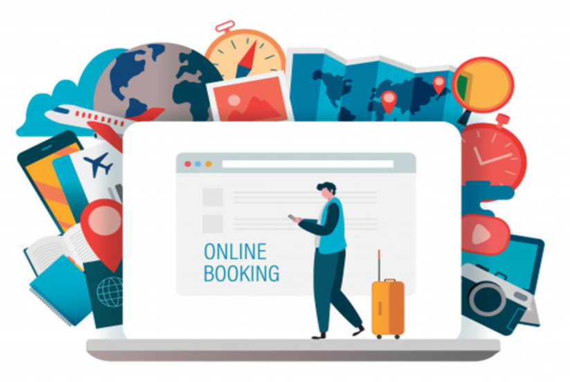

## **Steps for Online booking!!**

Follow the steps below to plan your Holiday in an easy way

* Once you open the application it will take you to the login page.
* You need to fill your credentials like username and password.
* This will open a page where you can select the booking you want to proceed for.
* Bus ticket booking
* Hotel room booking
* Train ticket booking
* Food Ordering
* Movie ticket booking
* From the above options you need select one and proceed for the further process.
* In the next page you get to fill some of your details for the process of booking.
* After that you will proceed for the payment process.
* Once you complete the payment you are free to logout the application.
* You can verify the payment details whenever needed just by logging in to the application.
* There is also possibility for cancelling your plan and the money will be refunded accordingly.
* Following the above process you can do different kind of bookings .

**SWOT ANALYSIS**

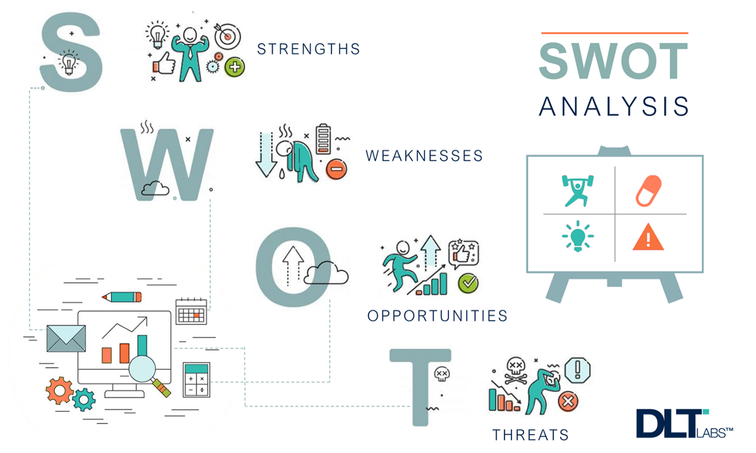

### Strengths

* Easy booking from home.
* High level of customer satisfaction.
* Most affordable with excellent services.

### Weaknesses

* Seasonal disturbances in demand.
* Dependency on systems.

### Opportunities

* Global expansion in overseas market.
* Expanding system features.
* Opportunities for niche transportation systems.

### Threats

* Less reliability on online payments.
* Occurrence of glitches in applications or websites.

**REQUIREMENTS**

## **Cost and Features**

### Cost

* The cost may vary depending on the travel routes.
* It may depend on the type of room the user want to book.

### Features

The various features of online bookings are:

* Login credentials to go for the further process.
* After Logging in the booking process starts according to the selected one.

## **Bus ticket Booking:** Book a ticket**,** Display details**,** Cancel a ticket

## **Hotel Booking:** Book a room, Type of hotel/room, View customer record, Search customer record

## **Railway ticket Booking:** Reserve a ticket, Cancel booking, Display passenger details

## **Food Ordering:** Order food**,** View food menu**,** View various Restaurant**,** Cancel food order

## **Movie Ticket Booking:** View current shows, view venue, date and time**,** book ticket**,** cancel ticket

* Logout after completion of the whole process.

# 4W's and 1'H

**Who:**

The tool is a helping hand for all the citizens to reserve their railway or bus tickets,to block their rooms in a hotel or book a cinema or order a food all at one place.

**What:**

Makes reservations and bookings in seconds without any difficulties.

**When:**

Anytime

**Where:**

Anywhere with internet connection.

**How:**

Opening the website or mobile app and filling the details required.

# Detail requirements (High level & Low level Requirements):

# Table-1: High Level Requirements:

| **ID** | **Feature** | **Description** | **Status** |
| --- | --- | --- | --- |
| HR_01 | Bus booking System | Booking | Implemented |
| HR_02 | Displaying | Implemented |
| HR_03 | Cancelling | Implemented |
| HR_04 | Discounts if any | Future |
| HR_05 | Hotel Booking System  Hotel Booking System | Type of hotel/room | Implemented |
| HR_06 | Book a room | Implemented |
| HR_07 | View/search for details | Implemented |
| HR_08 | Changing the plan | Future |
| HR_09 | Railway Ticket Booking | Booking/Cancelling ticket | Implemented |
| HR_10 | Viewing | Implemented |
| HR_11 | Tracking | Future |
| HR_12 | App development | Future |
| HR_13 | Food Ordering | Ordering food | Implemented |
| HR_14 | Displaying Restaurants and food menu | Implemented |
| HR_15 | Cancelling order | Implemented |
| HR_16 | Time tracking of available food | Future |
| HR_17 | Movie ticket booking System | current and upcoming movies | Implemented |
| HR_18 | Display venue and date/time | Implemented |
| HR_19 | Display available seats according to price | Implemented |
| HR_20 | Payment mode | Implemented |

## **Table-2: Low level Requirements:**

| **ID** | **Description** | **HLR ID** | **Status (Implemented/Future)** |
| --- | --- | --- | --- |
| LR_01 | Name | HR_01 | Implemented |
| LR_02 | Bus number | HR_02 | Implemented |
| LR_03 | Unique ID | HR_01, HR_02 | Implemented |
| LR_04 | Seat Chosen | HR_01 | Implemented |
| LR_05 | Cancel Confirmation | HR_03 | Implemented |
| LR_06 | List of the hotels | HR_05 | Implemented |
| LR_07 | Name of the customer | HR_06, HR_07 | Implemented |
| LR_08 | Type of room, Number of people | HR_06 | Implemented |
| LR_09 | Date of check-in/Check-out | HR_06 | Implemented |
| LR_10 | Changing the plan | HR_08 | Future |
| LR_11 | Name, Age | HR_09,HR_10 | Implemented |
| LR_12 | Starting point, Destination point | HR_09 | Implemented |
| LR_13 | Registration number | HR_10 | Implemented |
| LR_14 | Info about train, Live route | HR_11 | Future |
| LR_15 | Food Name, Quantity, Restaurant place | HR_13,HR_14 | Implemented |
| LR_16 | Food price and name | HR_14 | Implemented |
| LR_17 | Restaurant Place | HR_15 | Implemented |
| LR_18 | Available food, Food quantity | HR_16 | Future |
| LR_19 | List of movies in particular venue | HR_18 | Implemented |
| LR_20 | Audio quality in a particular seat | HR_19 | Implemented |
| LR_21 | Payment result | HR_20 | Implemented |
| LR_22 | Seats available for physically challenged | HR_19 | Future |

**Design:**

In the design system it is divided into high level and low level design. In the High Level Design, the product is explained in detail with help of Structural and behavioral Diagrams.

**High Level Design**

**Figure 1: ER Diagram:**

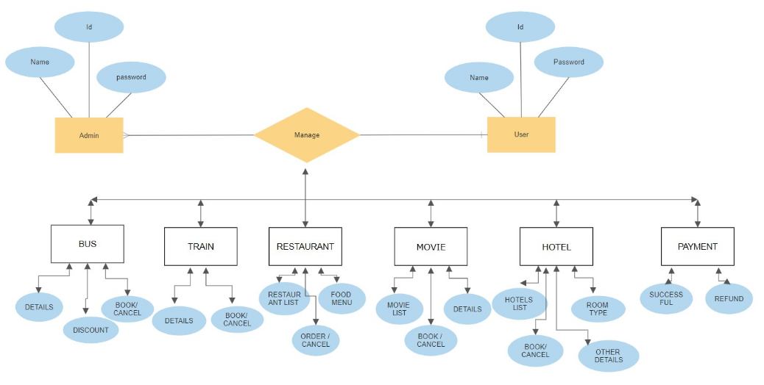

**Figure 2: Block Diagram:**

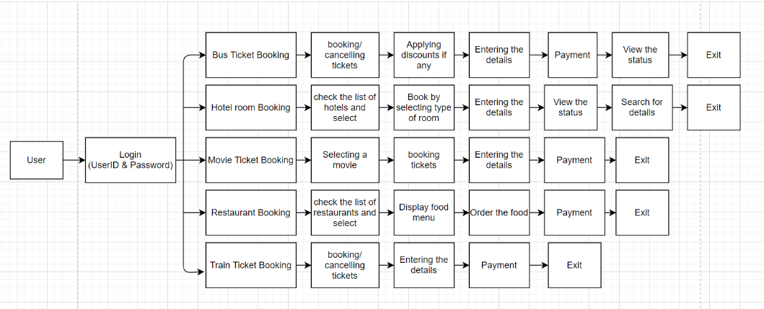

**Figure 3: Activity Diagram:**

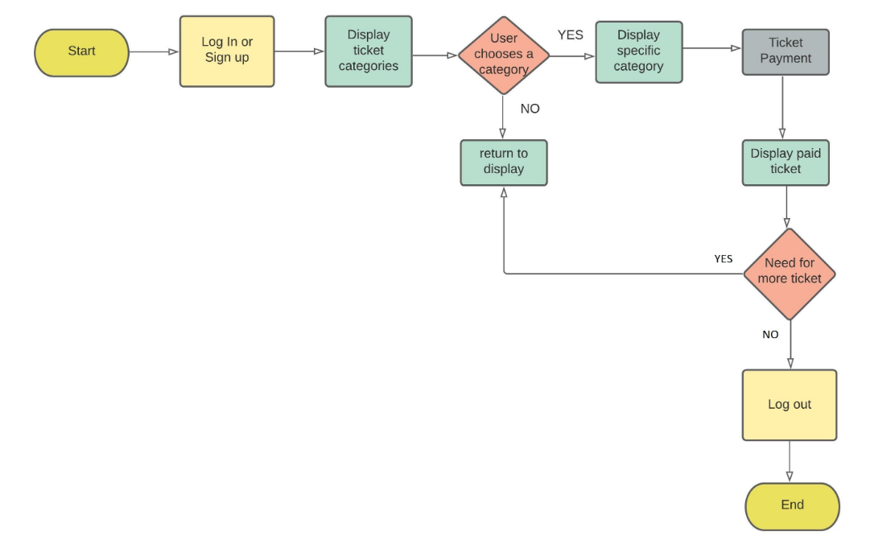

**Figure 4: Usecase Diagram:**

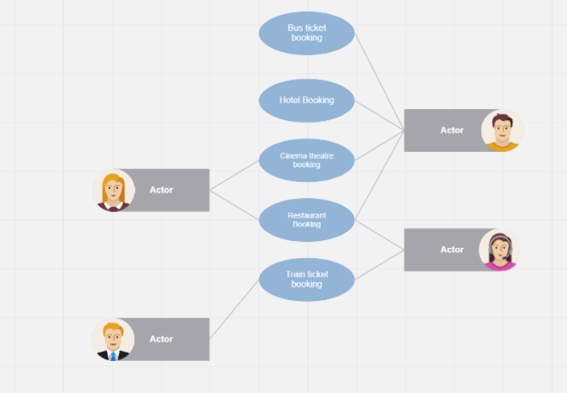

**Low Level Design**

**Bus ticket booking:**

**Figure 5: a) Use case Diagram:**

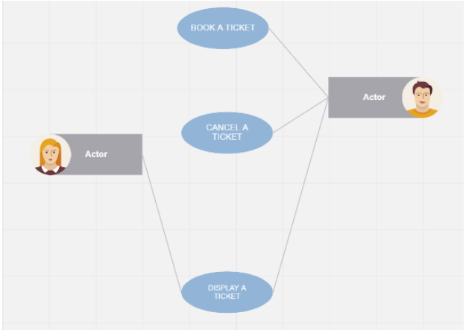

**Figure 5: b) Flow chart Diagram:**

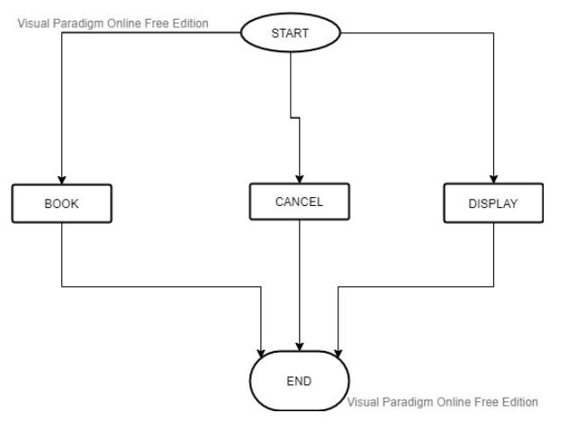

**Figure 5: c) Activity Diagram:**

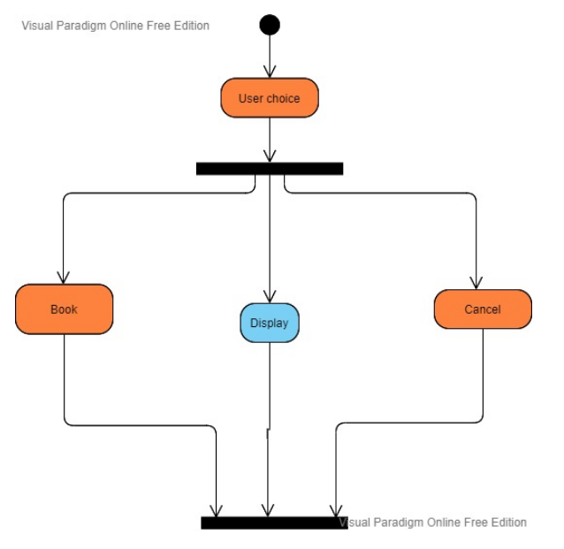

**Figure 5: d) Class Diagram:**

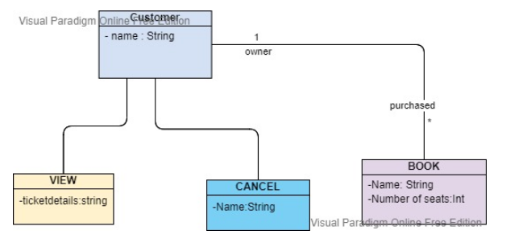

**Hotel booking:**

**Figure 6: a) Use case Diagram:**

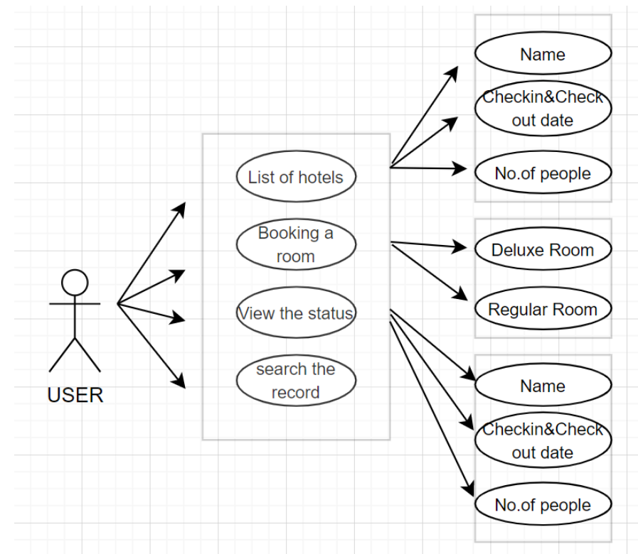

**Figure 6: b) Sequence Diagram:**

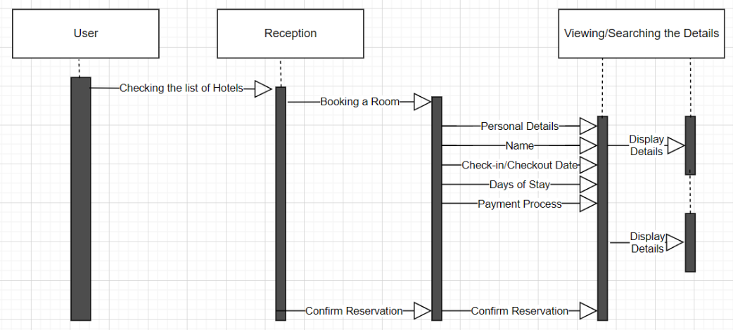

**Figure 6: c) Flow chart:**

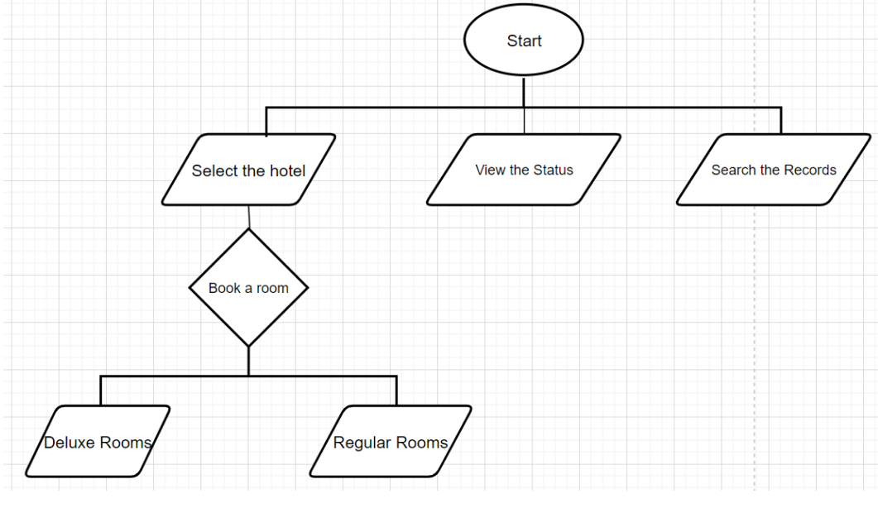

**Figure 6: d) Activity Diagram:**

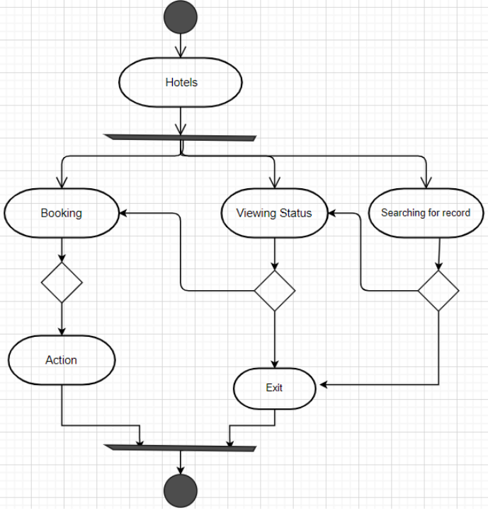

**Railway ticket booking:**

**Figure 7: a) Use case Diagram:**

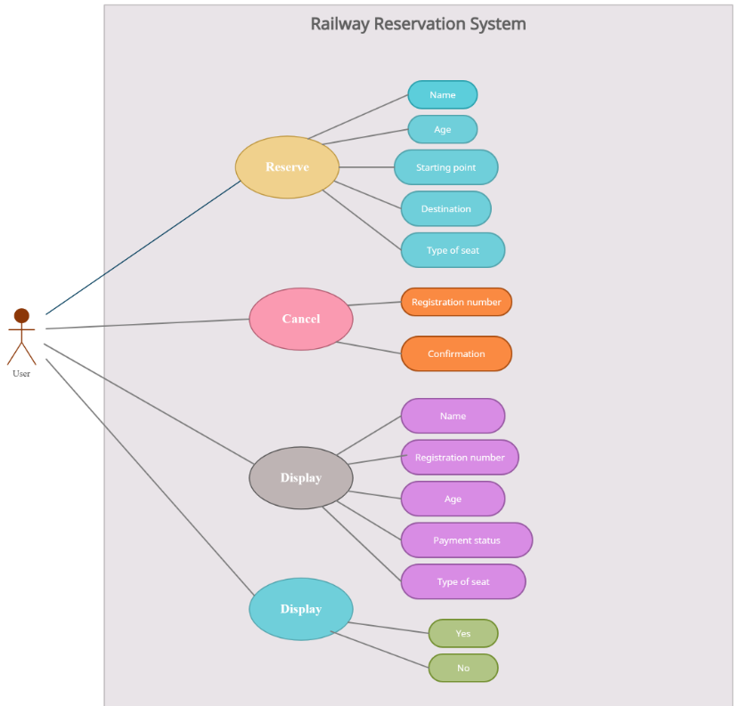

**Figure 7: a) Flow chart:**

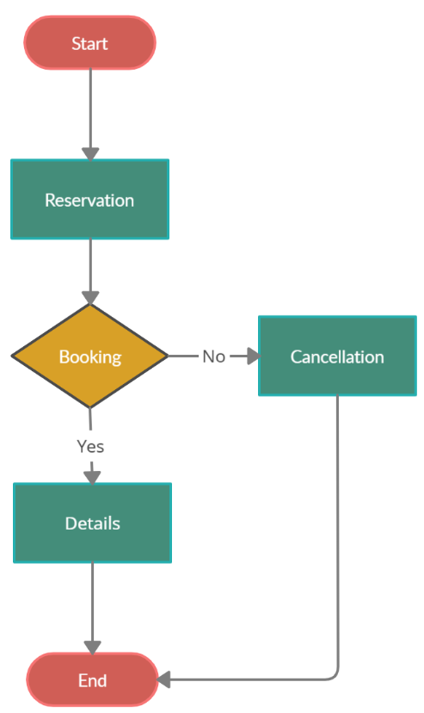

**Figure 7: c) System Diagram:**

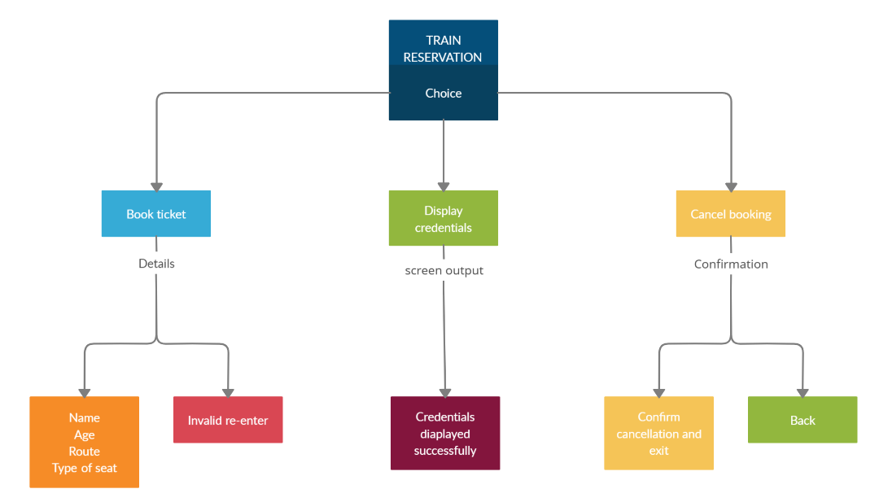

**Figure 7: d) Activity Diagram:**

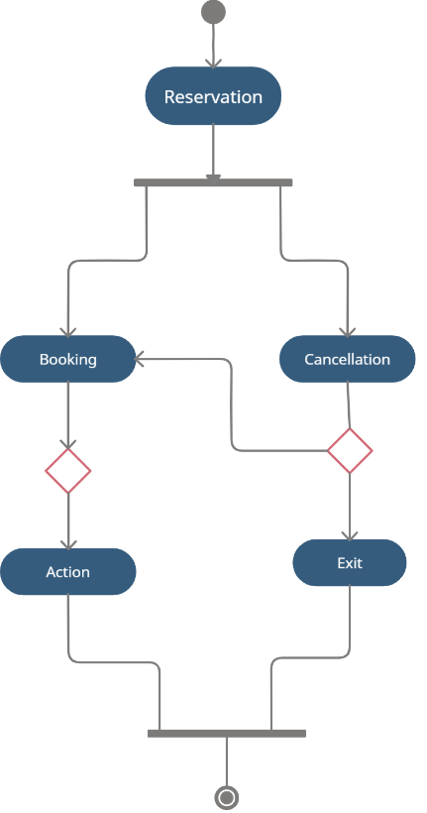

**Food Ordering:**

**Figure 8: a) Activity Diagram:**

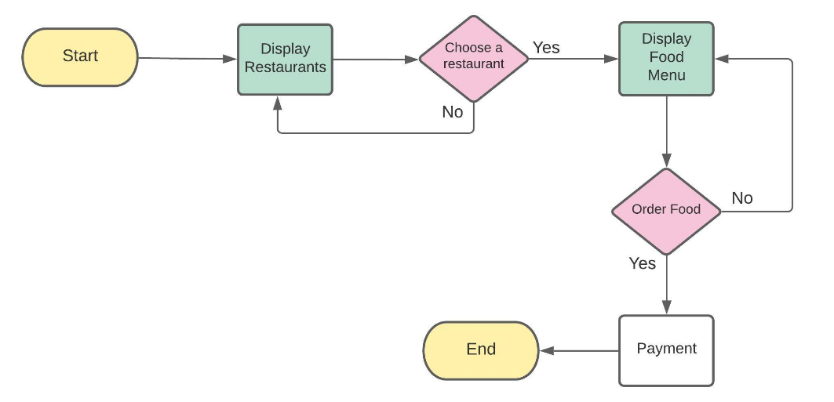

**Figure 8: b) Sequence Diagram:**

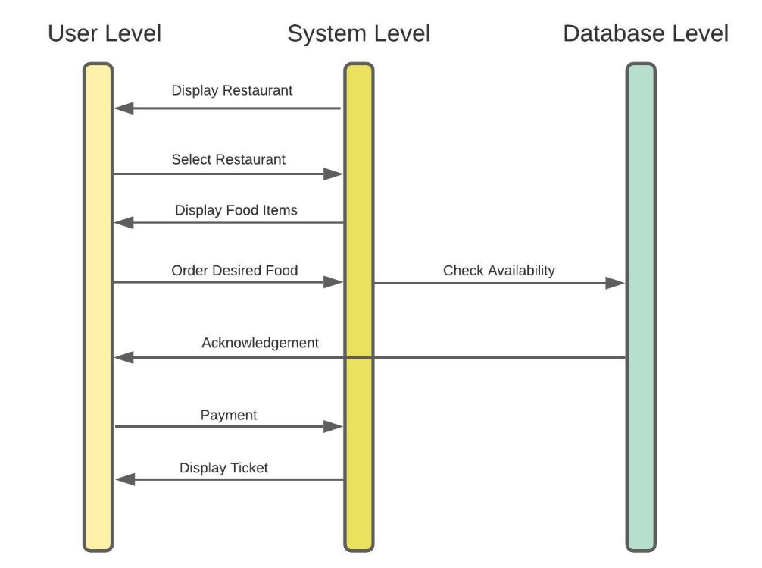

**Figure 8: c) Class Diagram:**

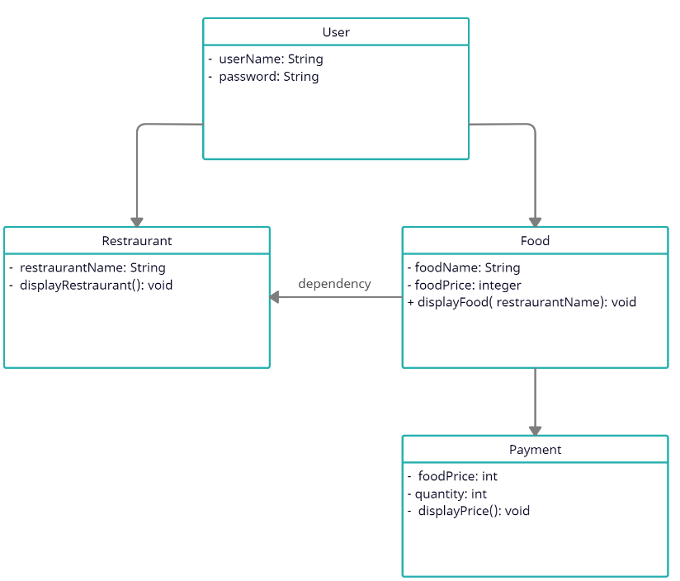

**Figure 8: d) Block Diagram:**

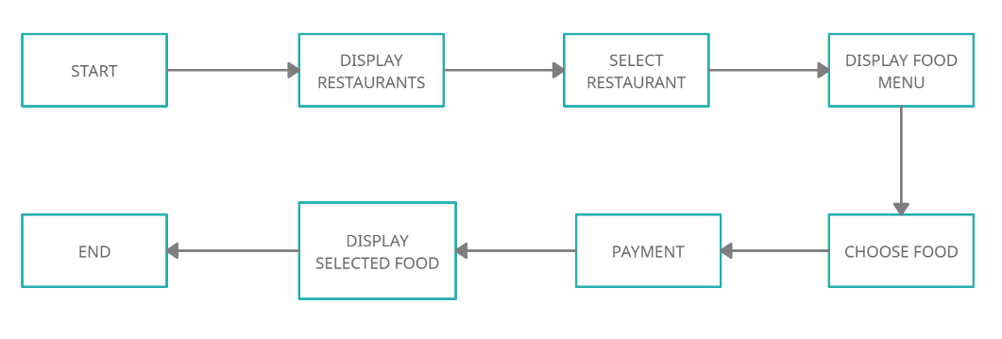

**Movie ticket booking:**

**Figure 9: a) Class Diagram:**

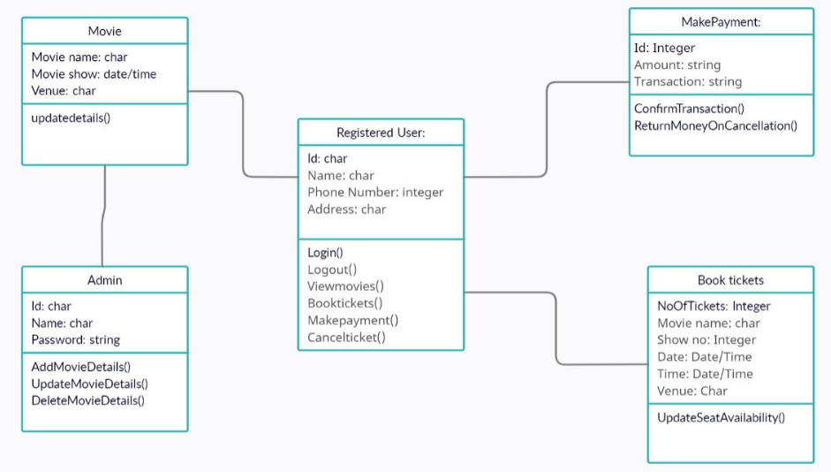

**Figure 9: b) Flow chart:**

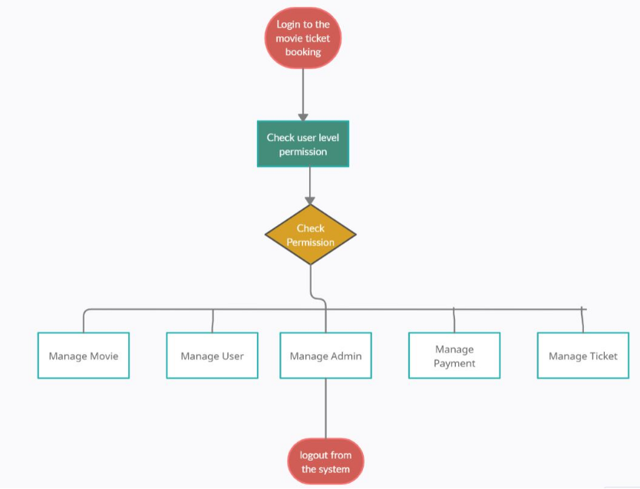

**Figure 9: c) DataFlow Diagram:**

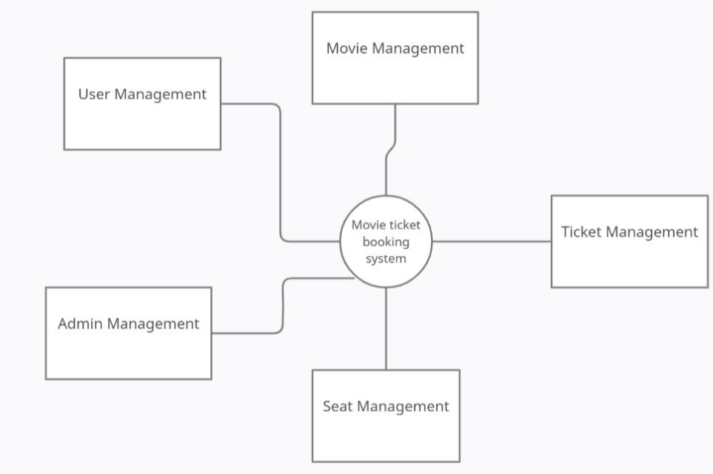

**Figure 9: d) Usecase Diagram:**

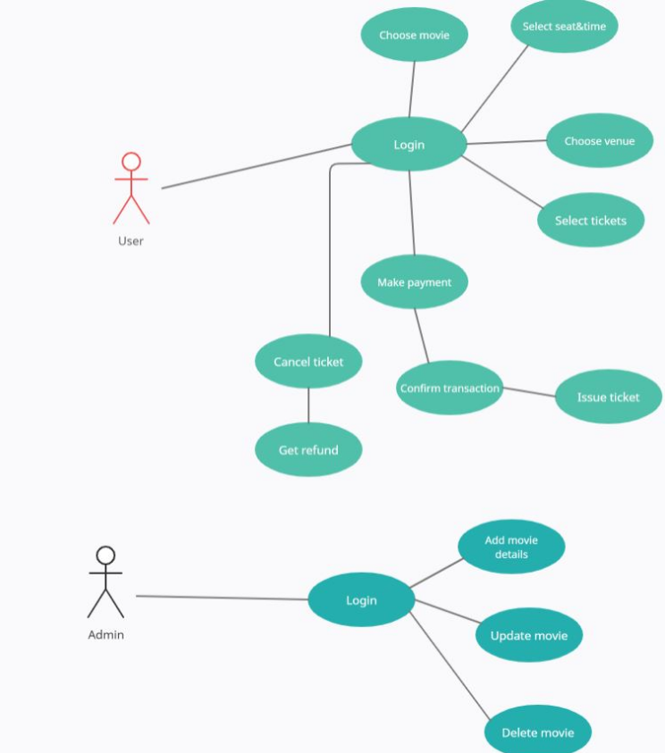

# TEST PLAN

## **Table -3 : High level Test Plan**

| **Test ID** | **Description** | **Actual Out** | **Type Of Test** |
| --- | --- | --- | --- |
| H_01 | Login credentials username and password | PASSING | Additional Requirement based |
| H_02 | Bookings for Holiday all booking functions | PASSING | Requirement based |
| H_03 | Displaying of tickets all displaying of booking function | PASSING | Requirement based |
| H_04 | Cancellation cancelling of booked ticket | PASSING | Requirement based |
| H_05 | Integrating all booking functions of different domain | PASSING | Requirement based |

## **Table – 4 : Low level Test Plan**

| **Test ID** | **HLT ID** | **Description** | **Features** | **Actual Out** | **Type Of Test** |
| --- | --- | --- | --- | --- | --- |
| L_01 | H_01 | Username/Password | Login | PASSING | Requirement based |
| L_02 | H_02 | Choosing and entering the details | Booking | PASSING | Requirement based |
| L_03 | H_03 | Details of the available trains | Displaying | PASSING | Requirement based |
| L_04 | H_04 | Cancelling the tickets | Cancelling | PASSING | Requirement based |
| L_05 | H_03 | Selecting different Types of Hotels and Rooms | Choosing | PASSING | Option based |
| L_06 | H_02 | Booking a room | Booking | PASSING | Requirement based |
| L_07 | H_03 | Searching and viewing the details | Displaying | PASSING | Requirement based |
| L_08 | H_03 | Viewing the menu | Displaying | PASSING | Requirement based |
| L_09 | H_02 | Ordering the food | Ordering | PASSING | Option based |
| L_10 | H_03 | Confirming order through input features | Viewing | PASSING | Option based |
| L_11 | H_03 | Reviewing order | Displaying | PASSING | Additional Requirement based |
| L_12 | H_03 | Option to choose movie | Viewing | PASSING | Option based |
| L_13 | H_03 | Search for a particular movie | Find a movie | PASSING | Requirement based |
| L_14 | H_02 | Booking movie based on list | Book a movie | PASSING | Requirement based |
| L_15 | H_03 | viewing the transaction details after booking | Viewing | PASSING | Option based |

GIT ISSUES:

Figure-10: Closed Git issues

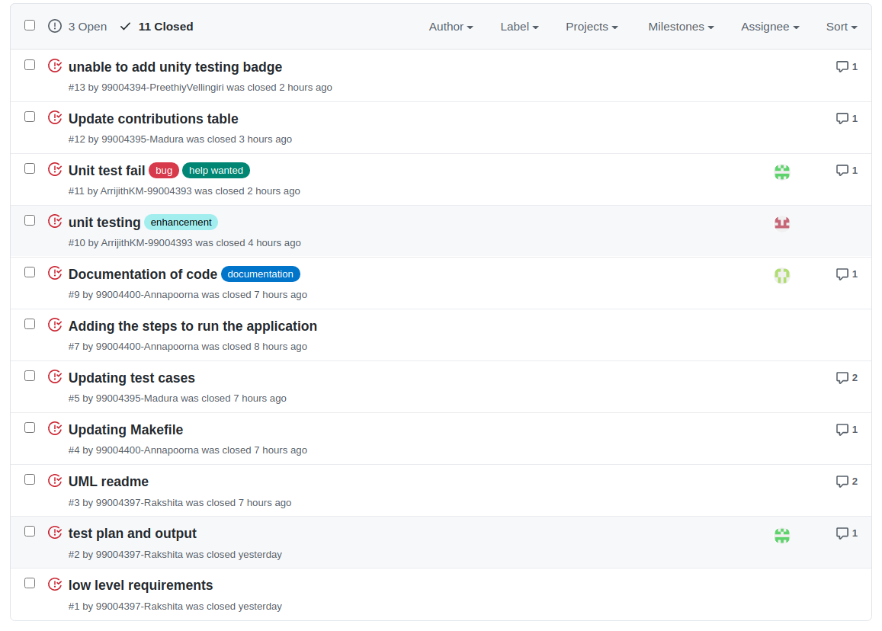

Figure-11: Open Git issues

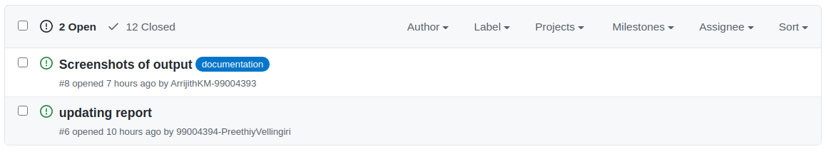

Figure-12: Git Commits-1:

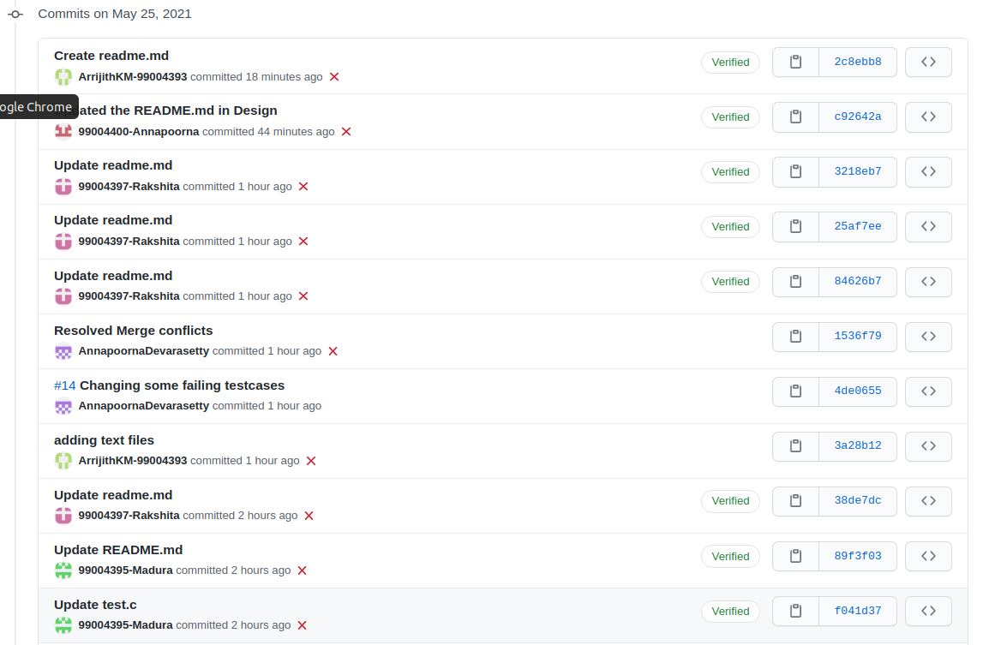

Figure-13: Git Commits-2

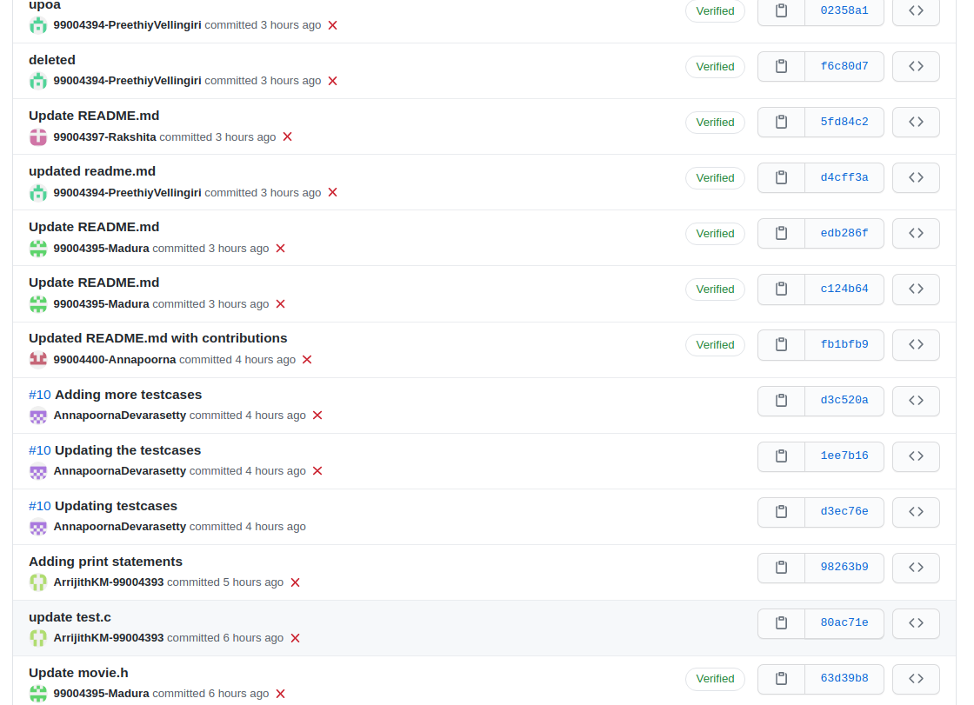

Figure-14: PROJECT KANBAN

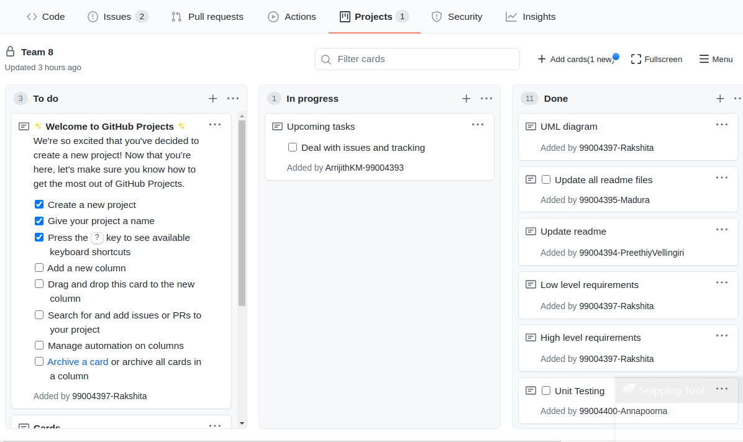

Figure -15: OUTPUT SCREEN-1

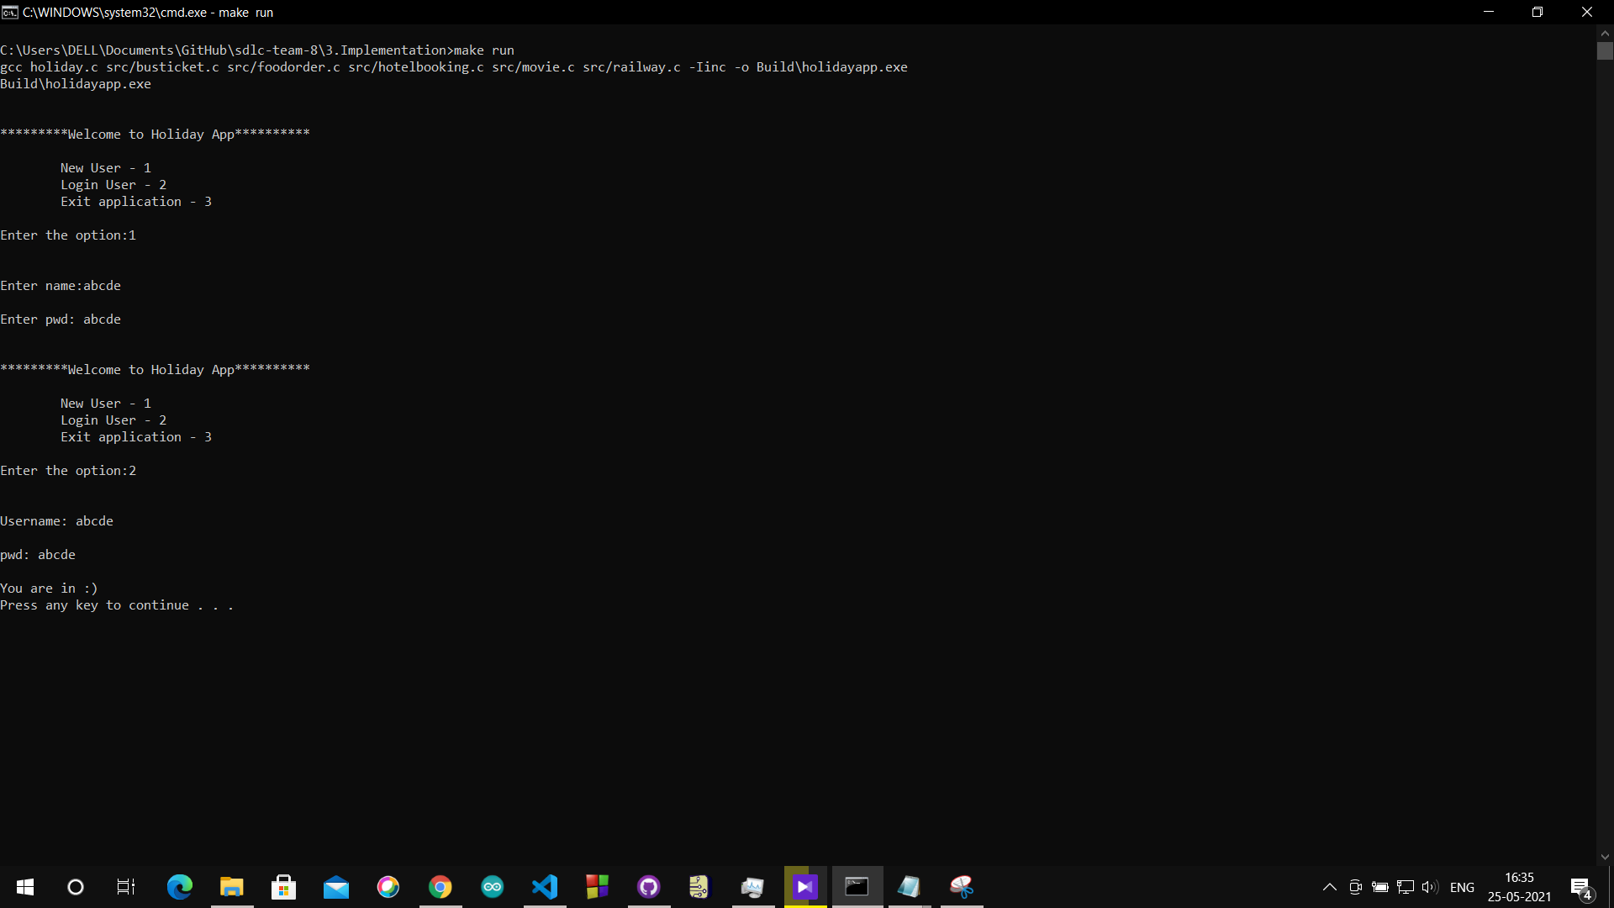

Figure -16: OUTPUT SCREEN-2

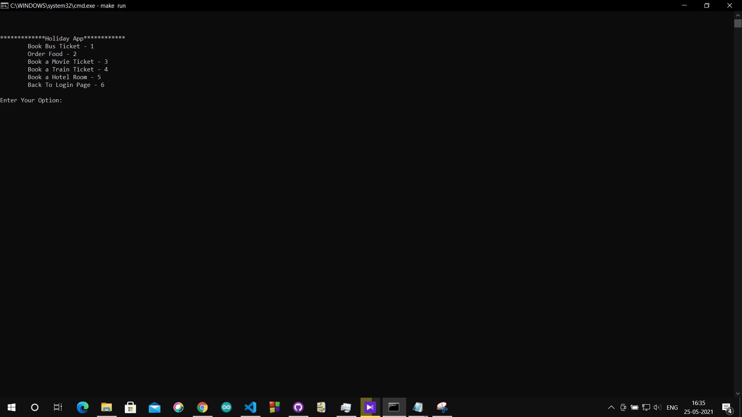

Figure -17: OUTPUT SCREEN-3

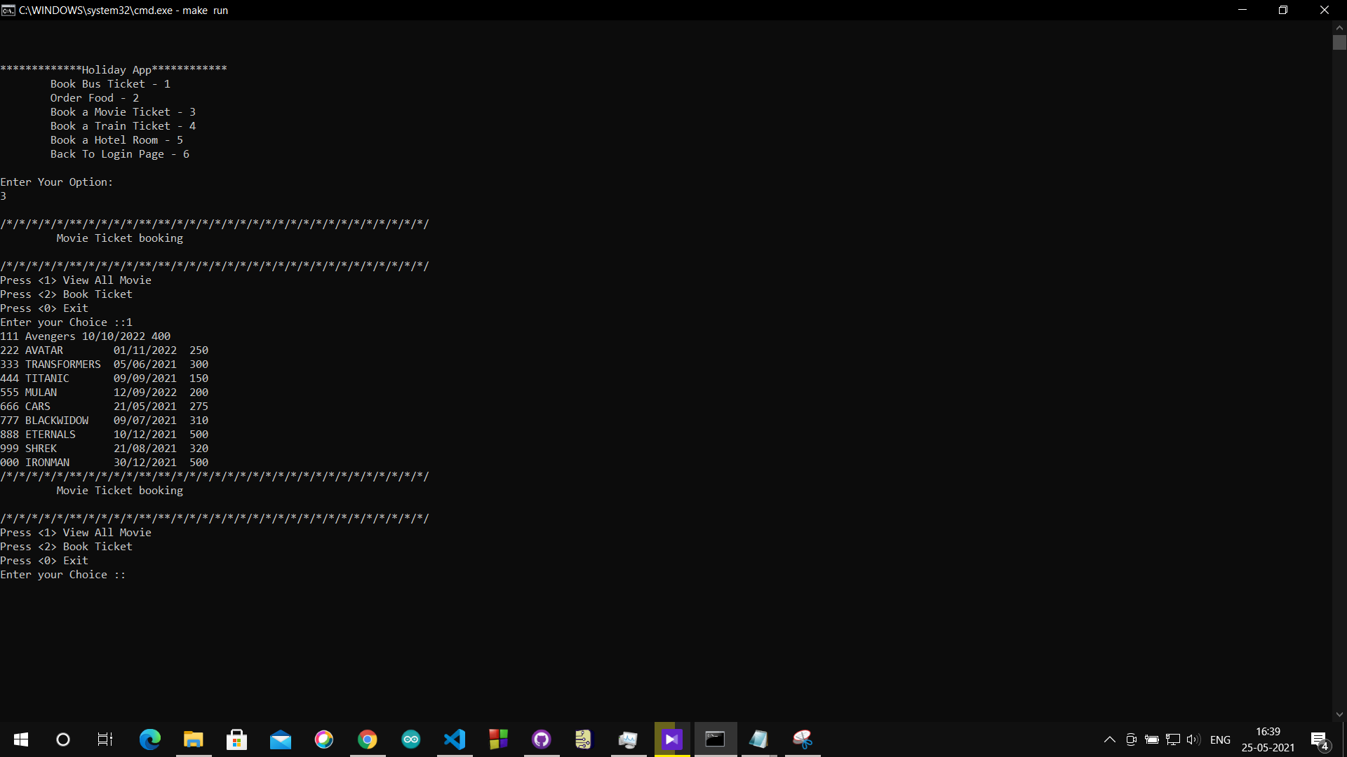

Figure -18: OUTPUT SCREEN-4

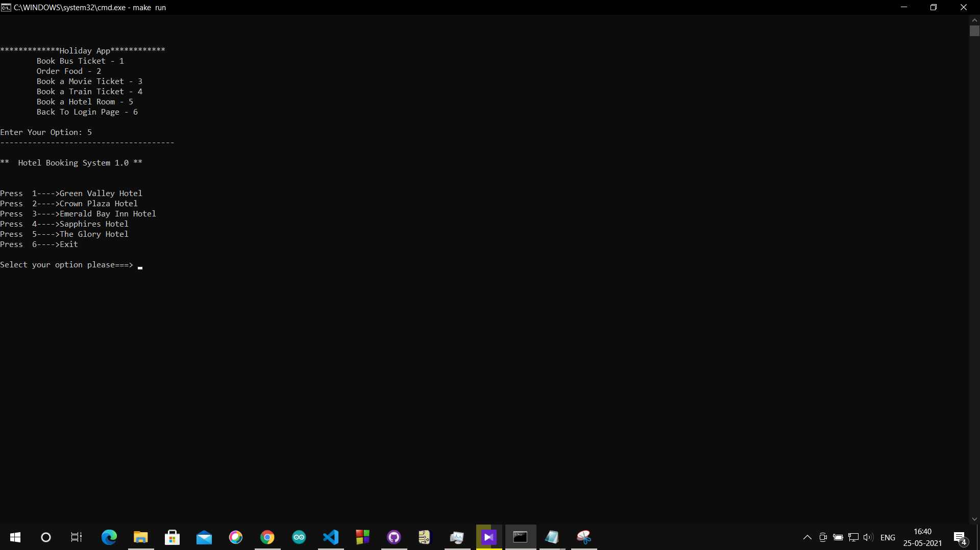

Figure -19: OUTPUT SCREEN-5

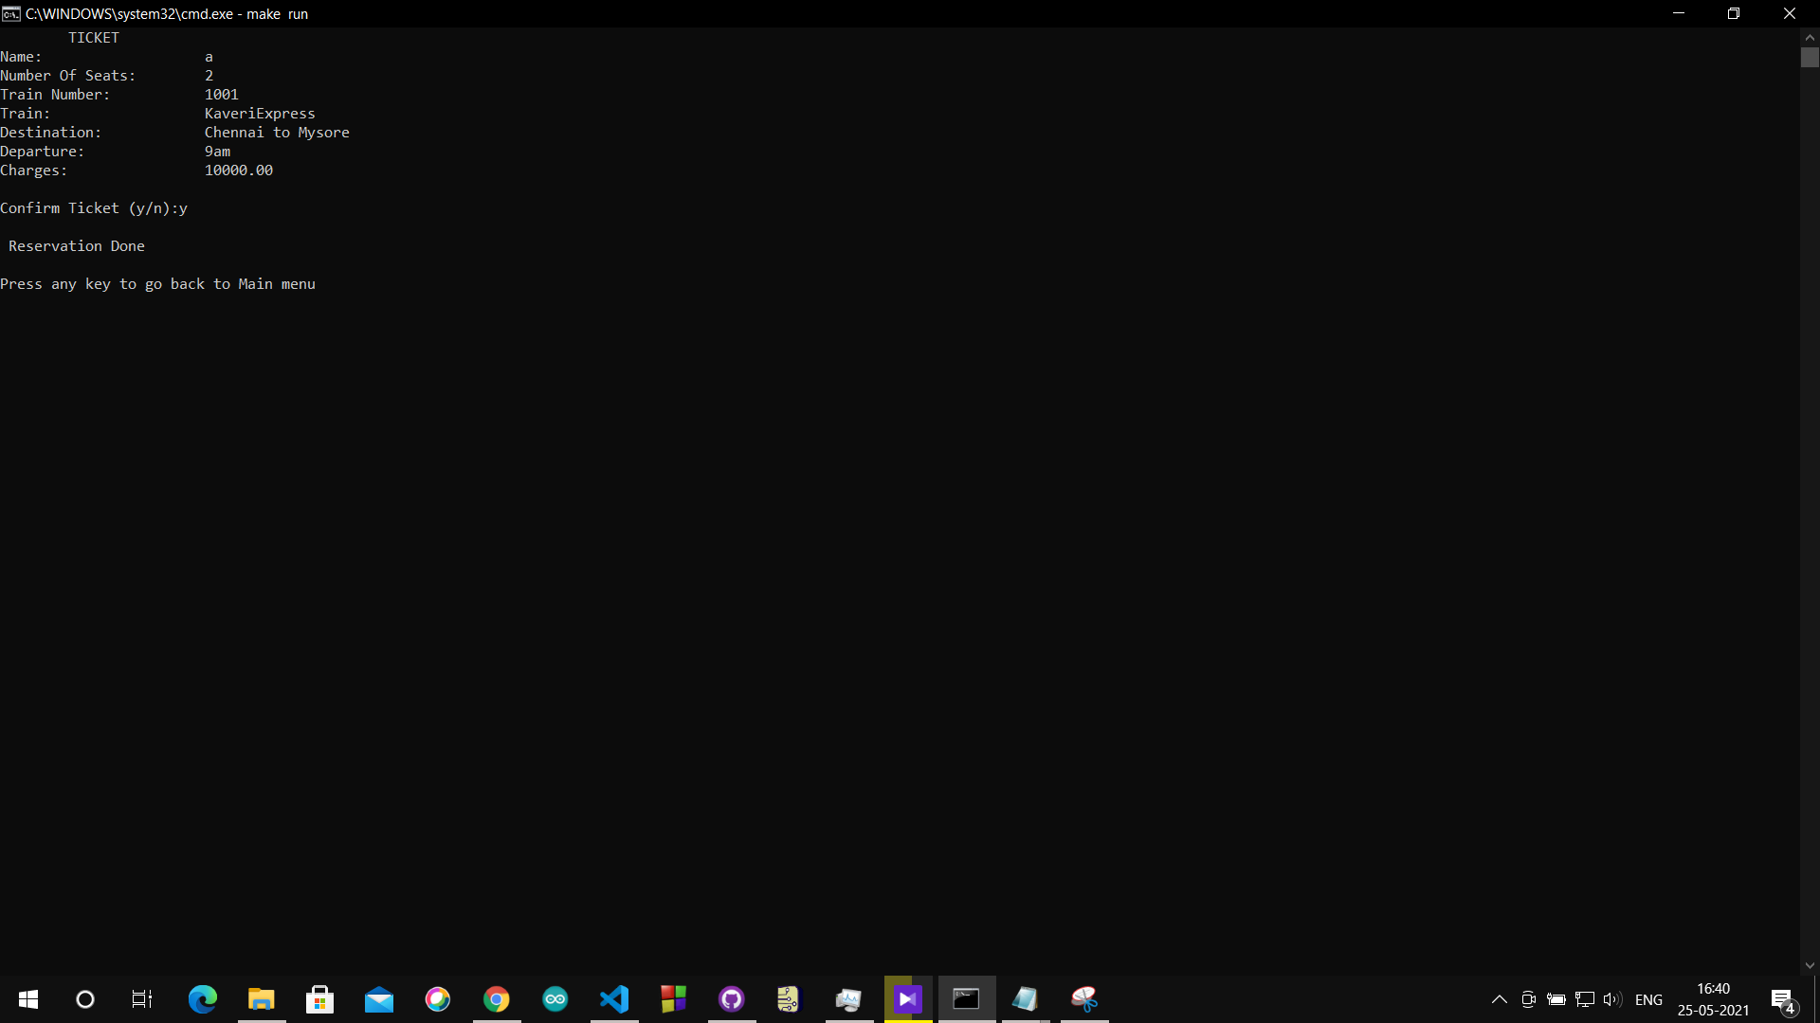

Figure-20: OUTPUT SCREEN-6

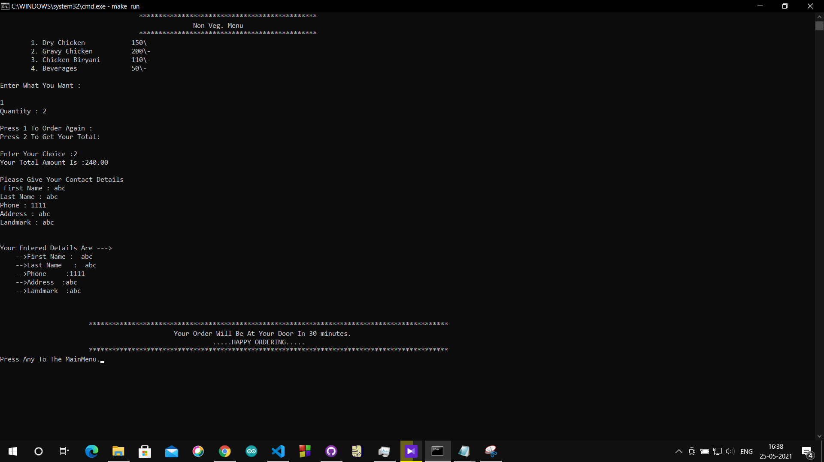

Figure-21: OUTPUT SCREEN-7

